**WEEK 7 REACT HANDS-ON**

**Exercise 9** – Cricket App with React

*App.js*

import React, { useState } from 'react';

import './App.css';

import ListofPlayers from './ListofPlayers';

import IndianPlayers from './IndianPlayers';

function App() {

  const [flag, setFlag] = useState(true);

  return (

    <div className="App">

      <h1>🏏 Cricket App With React 🏏</h1>

      <br></br><br></br>

      <button onClick={() => setFlag(!flag)}>

        Show {flag ? 'IndianPlayers' : 'ListofPlayers'}

      </button>

      {flag ? <ListofPlayers /> : <IndianPlayers />}

    </div>

  );

}

export default App;

*ListofPlayers.js*

import React from 'react';

const players = [

  { name: 'Virat', score: 80 },

  { name: 'Rohit', score: 45 },

  { name: 'Bumrah', score: 70 },

  { name: 'Rahul', score: 60 },

  { name: 'Hardik', score: 75 },

  { name: 'Shami', score: 55 },

  { name: 'Ishan', score: 35 },

  { name: 'Ashwin', score: 68 },

  { name: 'Surya', score: 90 },

  { name: 'Gill', score: 72 },

  { name: 'Kuldeep', score: 40 },

];

const ListofPlayers = () => {

  const highScorers = players.filter(player => player.score >= 70);

  return (

    <div>

      <h2>List of High-Scoring Players (≥70)</h2>

      <ul>

        {highScorers.map((player, index) => (

          <li key={index}>

            {player.name} - {player.score}

          </li>

        ))}

      </ul>

    </div>

  );

};

export default ListofPlayers;

*IndianPlayers.js*

import React from 'react';

const T20players = ['Virat', 'Rohit', 'Surya', 'Ishan', 'Gill'];

const RanjiTrophyPlayers = ['Shami', 'Ashwin', 'Kuldeep', 'Rahul', 'Hardik'];

const IndianPlayers = () => {

  const allPlayers = [...T20players, ...RanjiTrophyPlayers]; // merge arrays

  const oddPlayers = allPlayers.filter((_, index) => index % 2 !== 0);

  const evenPlayers = allPlayers.filter((_, index) => index % 2 === 0);

  return (

    <div>

      <h2>Odd Team Players</h2>

      <ul>

        {oddPlayers.map((player, index) => (

          <li key={index}>{player}</li>

        ))}

      </ul>

      <h2>Even Team Players</h2>

      <ul>

        {evenPlayers.map((player, index) => (

          <li key={index}>{player}</li>

        ))}

      </ul>

    </div>

  );

};

export default IndianPlayers;

*App.css*

body {

  margin: 0;

  font-family: Arial, sans-serif;

  background-image: url('bg_cricket.jpg');

  background-size: cover;

  background-repeat: no-repeat;

  background-position: center;

  color: white;

}

.App {

  background-color: rgba(0, 0, 0, 0.6);

  min-height: 100vh;

  padding: 40px;

  text-align: center;

}

h1, h2 {

  margin-bottom: 20px;

}

.table-container {

  display: flex;

  justify-content: center;

  margin-top: 30px;

}

table {

  width: 50%;

  border-collapse: collapse;

  background-color: white;

  color: black;

  border-radius: 8px;

  overflow: hidden;

}

th, td {

  padding: 12px 18px;

  border: 1px solid #ddd;

  text-align: center;

}

th {

  background-color: #282c34;

  color: white;

}

.App {

  text-align: center;

  padding: 20px;

  font-family: sans-serif;

}

ul {

  list-style-type: none;

  padding: 0;

}

li {

  margin: 5px 0;

}

h1 {

  animation: bounce 1s ease infinite alternate;

  font-size: 2.5rem;

  display: inline-block;

}

@keyframes bounce {

  0% { transform: translateY(0); }

  100% { transform: translateY(-8px); }

}

.App {

  animation: fadeIn 1.2s ease-in;

}

@keyframes fadeIn {

  from { opacity: 0; transform: translateY(10px); }

  to { opacity: 1; transform: translateY(0); }

}

**Output:**

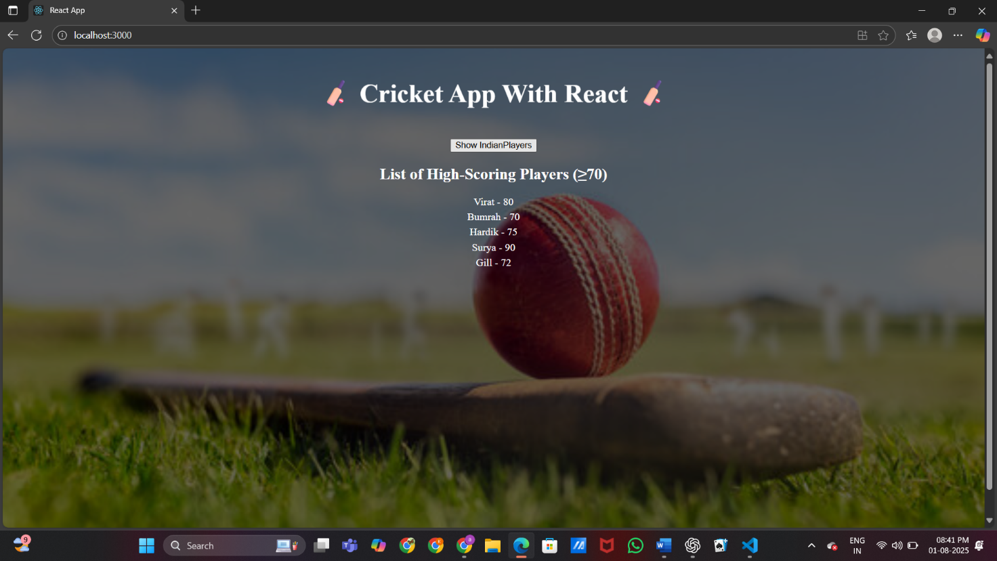

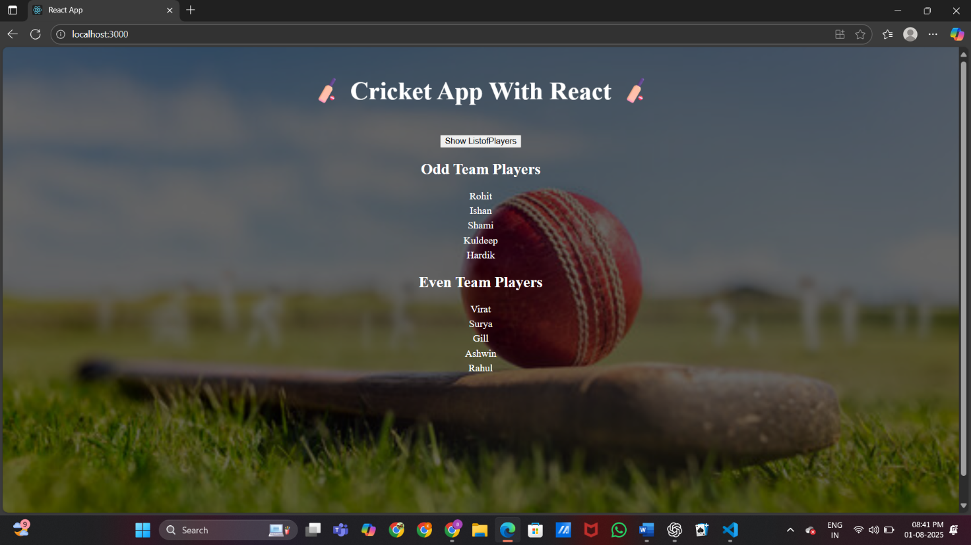

**Exercise 10 –** Office Parental App

*App.js*

import React from 'react';

function App() {

  const office = {

    name: 'Curated Spaces',

    rent: 100000,

    address: 'Chennai',

    image: 'office.jpg',

  };

  const rentStyle = {

    color: office.rent < 60000 ? 'red' : 'green',

    fontWeight: 'bold'

  };

  const containerStyle = {

    display: 'flex',

    flexDirection: 'column',

    alignItems: 'center',

    textAlign: 'center',

    padding: '40px',

    fontFamily: 'Arial, sans-serif',

    backgroundColor: '#66FFCC',

    minHeight: '100vh'

  };

  return (

    <div style={containerStyle}>

      <h1>🏢 Office Space at Affordable Range 🏢</h1>

      <img

        src={process.env.PUBLIC_URL + '/' + office.image}

        alt="Office"

        style={{ width: '300px', height: 'auto', margin: '20px 0' }}

      />

      <h2>Name: {office.name}</h2>

      <p style={rentStyle}>Rent: Rs. {office.rent}</p>

      <p><strong>Address:</strong> {office.address}</p>

    </div>

  );

}

export default App;

*Index.js*

import React from 'react';

import ReactDOM from 'react-dom/client';

import App from './App';

const root = ReactDOM.createRoot(document.getElementById('root'));

root.render(<App />);

*App.css*

.App {

  text-align: center;

}

.App-logo {

  height: 40vmin;

  pointer-events: none;

}

@media (prefers-reduced-motion: no-preference) {

  .App-logo {

    animation: App-logo-spin infinite 20s linear;

  }

}

.App-header {

  background-color: #282c34;

  min-height: 100vh;

  display: flex;

  flex-direction: column;

  align-items: center;

  justify-content: center;

  font-size: calc(10px + 2vmin);

  color: white;

}

.App-link {

  color: #61dafb;

}

@keyframes App-logo-spin {

  from {

    transform: rotate(0deg);

  }

  to {

    transform: rotate(360deg);

  }

}

**Output:**

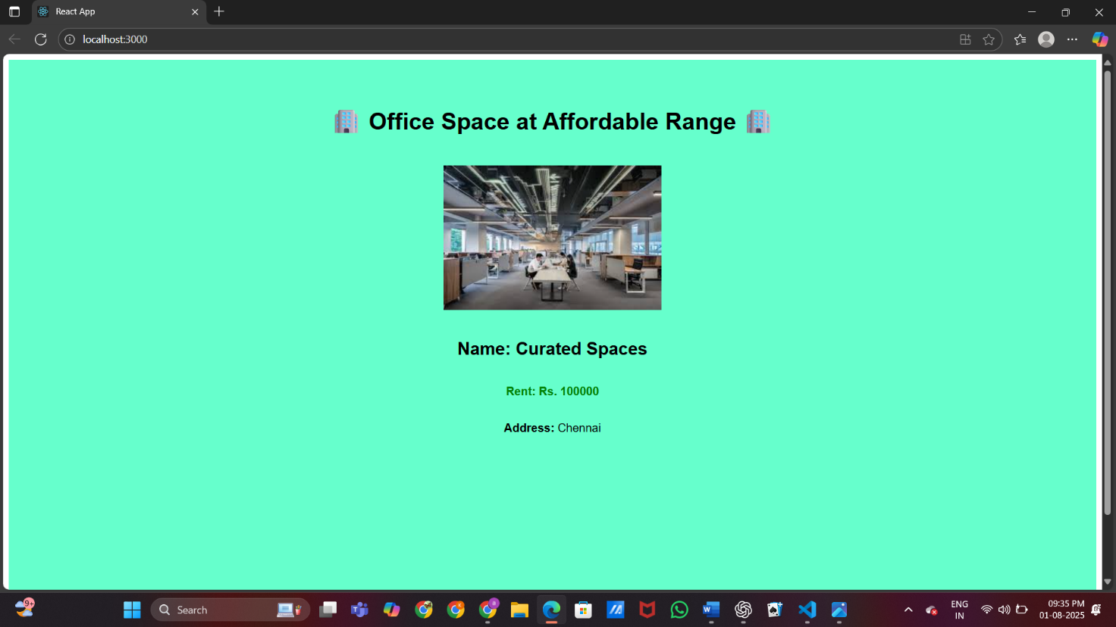**Exercise 11 -** Currency Converter App

*App.js*

import React, { useState } from 'react';

import CurrencyConvertor from './CurrencyConvertor';

import './App.css'; // Ensure this is imported

function App() {

  const [count, setCount] = useState(0);

  const [message, setMessage] = useState('');

  const [clickMessage, setClickMessage] = useState('');

  const increment = () => {

    setCount(prev => prev + 1);

    sayHello();

  };

  const decrement = () => {

    setCount(prev => prev - 1);

  };

  const sayHello = () => {

    setMessage('Hello! This is a static message.');

  };

  const sayMessage = (msg) => {

    setMessage(msg);

  };

  const handleClick = () => {

    setClickMessage("I was clicked");

  };

  return (

    <div className="app-container">

      <div className="content-box">

        <h1>Currency Convertor App</h1>

        <h2>Counter: {count}</h2>

        <button onClick={increment}>Increment</button>{' '}

        <button onClick={decrement}>Decrement</button>

        <hr />

        <button onClick={() => sayMessage("Welcome")}>Say Welcome</button>

        <p><strong>Message:</strong> {message}</p>

        <hr />

        <button onClick={handleClick}>Synthetic Event (Click Me)</button>

        <p><strong>Synthetic Message:</strong> {clickMessage}</p>

        <hr />

        <CurrencyConvertor />

      </div>

    </div>

  );

}

export default App;

*CurrencyConverter.js*

import React, { useState } from 'react';

function CurrencyConvertor() {

  const [rupees, setRupees] = useState('');

  const [converted, setConverted] = useState(null);

  const [currency, setCurrency] = useState('EUR');

  const conversionRates = {

    EUR: 90,

    USD: 83,

    GBP: 105,

  };

  const handleSubmit = () => {

    const rate = conversionRates[currency];

    const value = parseFloat(rupees);

    if (!isNaN(value)) {

      const result = value / rate;

      setConverted(result.toFixed(2));

    } else {

      setConverted(null);

    }

  };

  return (

    <div>

      <h2>Currency Converter</h2>

      <input

        type="number"

        placeholder="Enter amount in INR"

        value={rupees}

        onChange={(e) => setRupees(e.target.value)}

      />

      <select value={currency} onChange={(e) => setCurrency(e.target.value)}>

        <option value="EUR">Euro (EUR)</option>

        <option value="USD">US Dollar (USD)</option>

        <option value="GBP">British Pound (GBP)</option>

      </select>

      <button onClick={handleSubmit}>Convert</button>

      {converted !== null && (

        <p>

          {rupees} INR = <strong>{converted} {currency}</strong>

        </p>

      )}

    </div>

  );

}

export default CurrencyConvertor;

*App.css*

.app-container {

  background-image: url('currency.jpg'); /* if image is in public folder */

  background-size: cover;

  background-position: center;

  background-repeat: no-repeat;

  min-height: 100vh;

  display: flex;

  justify-content: center;

  align-items: center;

  color: white;

}

.content-box {

  background-color: rgba(0, 0, 0, 0.6); /* dark overlay */

  padding: 30px;

  border-radius: 10px;

  max-width: 600px;

  width: 100%;

}

button {

  margin: 5px;

  padding: 8px 16px;

  border: none;

  background-color: #61dafb;

  color: #000;

  cursor: pointer;

  font-weight: bold;

  border-radius: 4px;

}

button:hover {

  background-color: #21a1f1;

}

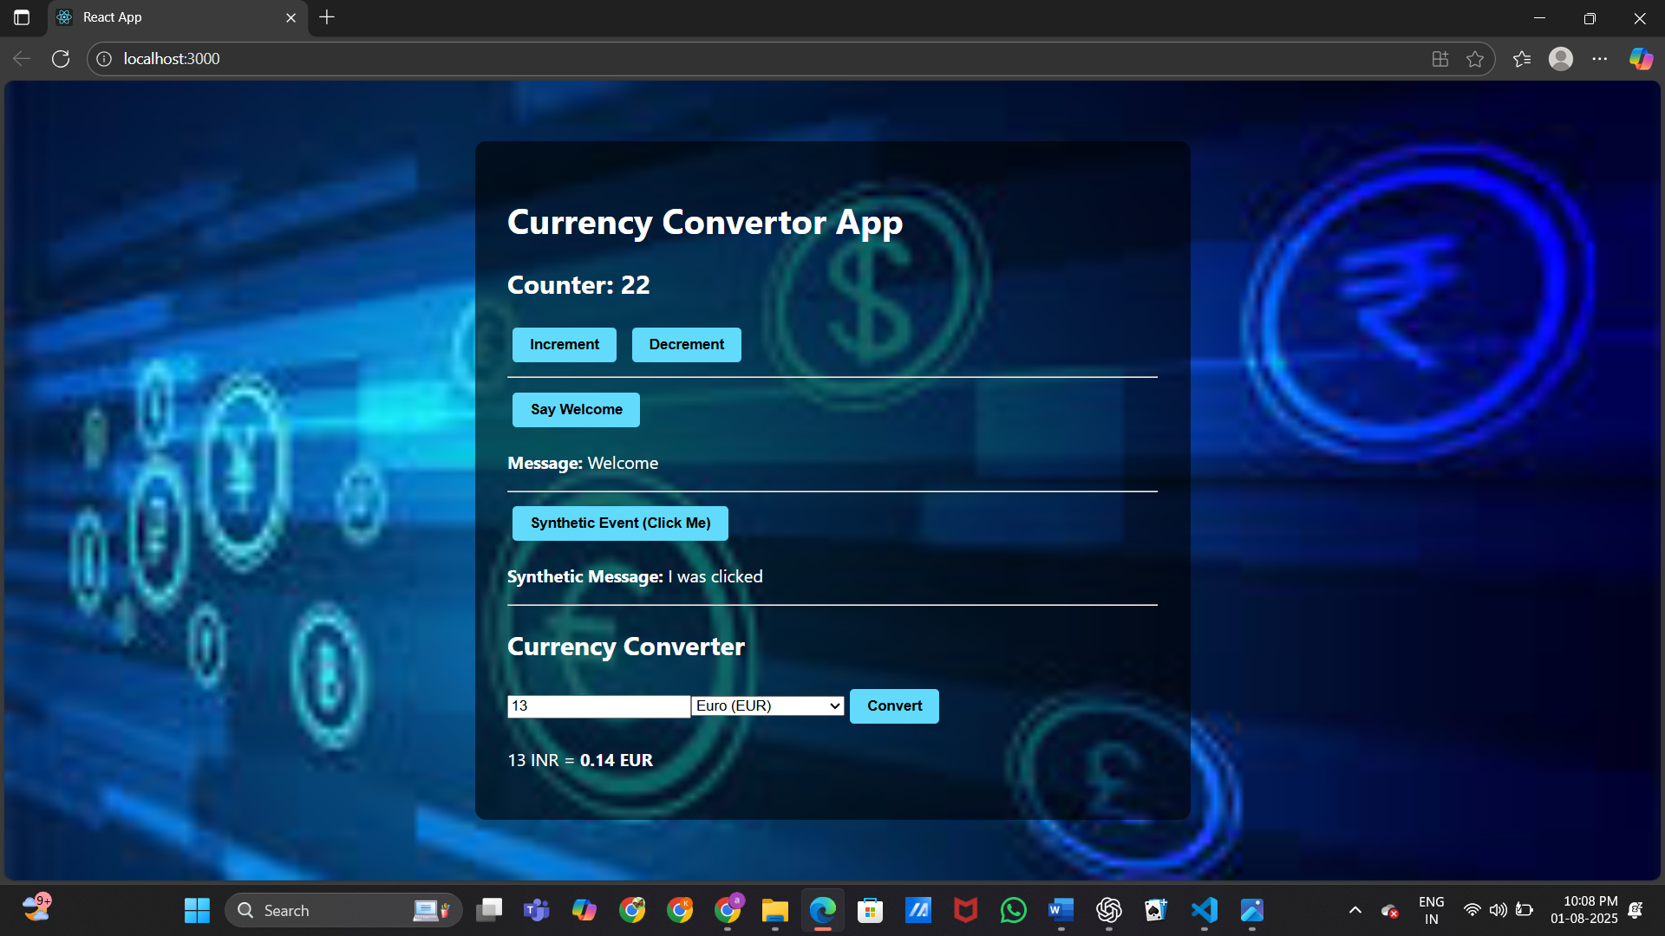**Output:**

**Exercise 12 -** Ticket Booking App

*App.js*

import React, { useState } from 'react';

import GuestPage from './GuestPage';

import UserPage from './UserPage';

import FlightDetails from './FlightDetails';

import './App.css';

function App() {

  const [isLoggedIn, setIsLoggedIn] = useState(false);

  const handleLogin = () => setIsLoggedIn(true);

  const handleLogout = () => setIsLoggedIn(false);

  const page = isLoggedIn ? (

    <UserPage onLogout={handleLogout} />

  ) : (

    <GuestPage onLogin={handleLogin} />

  );

  return (

    <div className="app-container">

      <div className="center-box">

        <h1>Ticket Booking App ✈️</h1>

        {page}

        <hr />

        <FlightDetails />

      </div>

    </div>

  );

}

export default App;

*Userpage.js*

import React, { useState } from 'react';

function UserPage({ onLogout }) {

  const [formData, setFormData] = useState({

    company: '',

    source: '',

    destination: '',

    date: '',

    time: '',

    seat: '',

  });

  const [submitted, setSubmitted] = useState(false);

  const [day, setDay] = useState('');

  const handleChange = (e) => {

    const { name, value } = e.target;

    setFormData((prev) => ({ ...prev, [name]: value }));

    if (name === 'date') {

      const selectedDate = new Date(value);

      const days = ['Sunday', 'Monday', 'Tuesday', 'Wednesday', 'Thursday', 'Friday', 'Saturday'];

      setDay(days[selectedDate.getDay()]);

    }

  };

  const handleSubmit = (e) => {

    e.preventDefault();

    if (formData.source === formData.destination) {

      alert('Source and destination must be different.');

      return;

    }

    setSubmitted(true);

  };

  return (

    <div>

      <h2>Welcome, User!</h2>

      <p>You can now book your flight.</p>

      <button onClick={onLogout}>Logout</button>

      <hr />

      {!submitted ? (

        <form onSubmit={handleSubmit}>

          <label>

            Airline Company:

            <select name="company" value={formData.company} onChange={handleChange} required>

              <option value="">--Select--</option>

              <option value="Air India">Air India</option>

              <option value="IndiGo">IndiGo</option>

              <option value="SpiceJet">SpiceJet</option>

              <option value="Vistara">Vistara</option>

            </select>

          </label>

          <label>

            Source:

            <select name="source" value={formData.source} onChange={handleChange} required>

              <option value="">--Select--</option>

              <option value="Delhi">Delhi</option>

              <option value="Mumbai">Mumbai</option>

              <option value="Chennai">Chennai</option>

              <option value="Hyderabad">Hyderabad</option>

              <option value="Bangalore">Bangalore</option>

            </select>

          </label>

          <label>

            Destination:

            <select name="destination" value={formData.destination} onChange={handleChange} required>

              <option value="">--Select--</option>

              <option value="Delhi">Delhi</option>

              <option value="Mumbai">Mumbai</option>

              <option value="Chennai">Chennai</option>

              <option value="Hyderabad">Hyderabad</option>

              <option value="Bangalore">Bangalore</option>

            </select>

          </label>

          <label>

            Date:

            <input type="date" name="date" value={formData.date} onChange={handleChange} required />

          </label>

          <label>

            Time:

            <input type="time" name="time" value={formData.time} onChange={handleChange} required />

          </label>

          <label>

            Seat Preference:

            <select name="seat" value={formData.seat} onChange={handleChange} required>

              <option value="">--Select--</option>

              <option value="Window">Window</option>

              <option value="Aisle">Aisle</option>

              <option value="Middle">Middle</option>

            </select>

          </label>

          <button type="submit">Book Flight</button>

        </form>

      ) : (

        <div>

          <h3>Booking Confirmed!</h3>

          <p><strong>Airline:</strong> {formData.company}</p>

          <p><strong>From:</strong> {formData.source}</p>

          <p><strong>To:</strong> {formData.destination}</p>

          <p><strong>Date:</strong> {formData.date}</p>

          <p><strong>Day:</strong> {day}</p>

          <p><strong>Time:</strong> {formData.time}</p>

          <p><strong>Seat:</strong> {formData.seat}</p>

        </div>

      )}

    </div>

  );

}

export default UserPage;

*GuestPage.js*

import React from 'react';

function GuestPage({ onLogin }) {

  return (

    <div>

      <h2>Welcome, Guest!</h2>

      <p>Please log in to book a flight.</p>

      <button onClick={onLogin}>Login</button>

    </div>

  );

}

export default GuestPage;

*FlightDetails.js*

import React from 'react';

function FlightDetails() {

  return (

    <div>

      <h3>Available Flights</h3>

      <ul>

        <li>AI-101 | Delhi → Mumbai | 9:00 AM</li>

        <li>SG-202 | Chennai → Bangalore | 1:30 PM</li>

        <li>6E-303 | Hyderabad → Delhi | 6:45 PM</li>

      </ul>

    </div>

  );

}

export default FlightDetails;

*App.css*

.app-container {

  display: flex;

  justify-content: center;

  align-items: center;

  min-height: 100vh;

  font-family: Arial, sans-serif;

  background-color: #f2f4f8;

  padding: 20px;

}

.center-box {

  background-color: white;

  padding: 30px;

  border-radius: 12px;

  box-shadow: 0 4px 12px rgba(0, 0, 0, 0.1);

  width: 100%;

  max-width: 600px;

}

form label {

  display: block;

  margin-top: 12px;

  font-weight: 500;

}

input,

select {

  width: 100%;

  padding: 8px;

  margin-top: 4px;

  margin-bottom: 10px;

  border-radius: 6px;

  border: 1px solid #ccc;

}

button {

  padding: 10px 18px;

  background-color: #1976d2;

  color: white;

  font-weight: bold;

  border: none;

  border-radius: 6px;

  cursor: pointer;

  margin-top: 12px;

}

button:hover {

  background-color: #0d47a1;

}

**Output:**

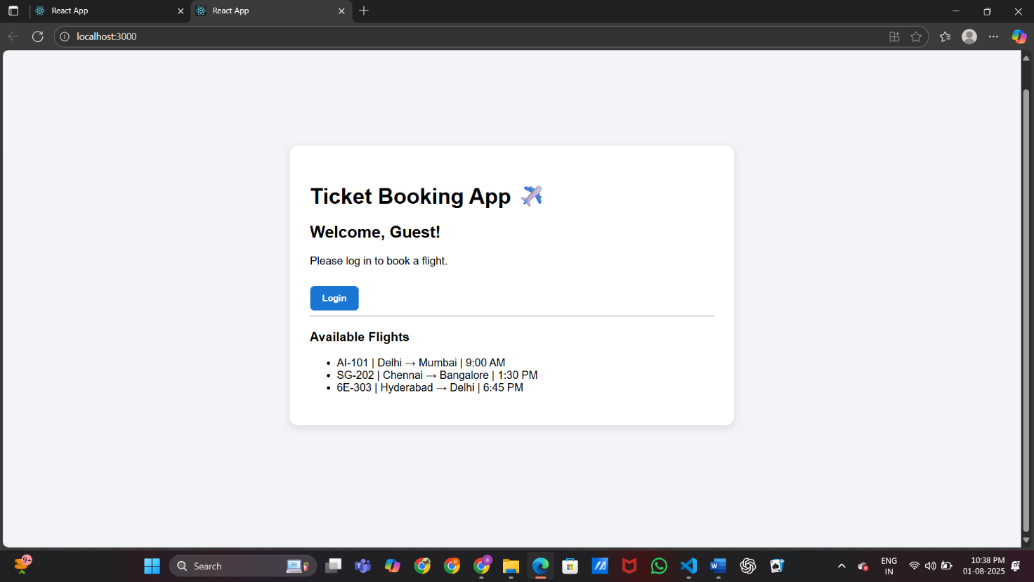

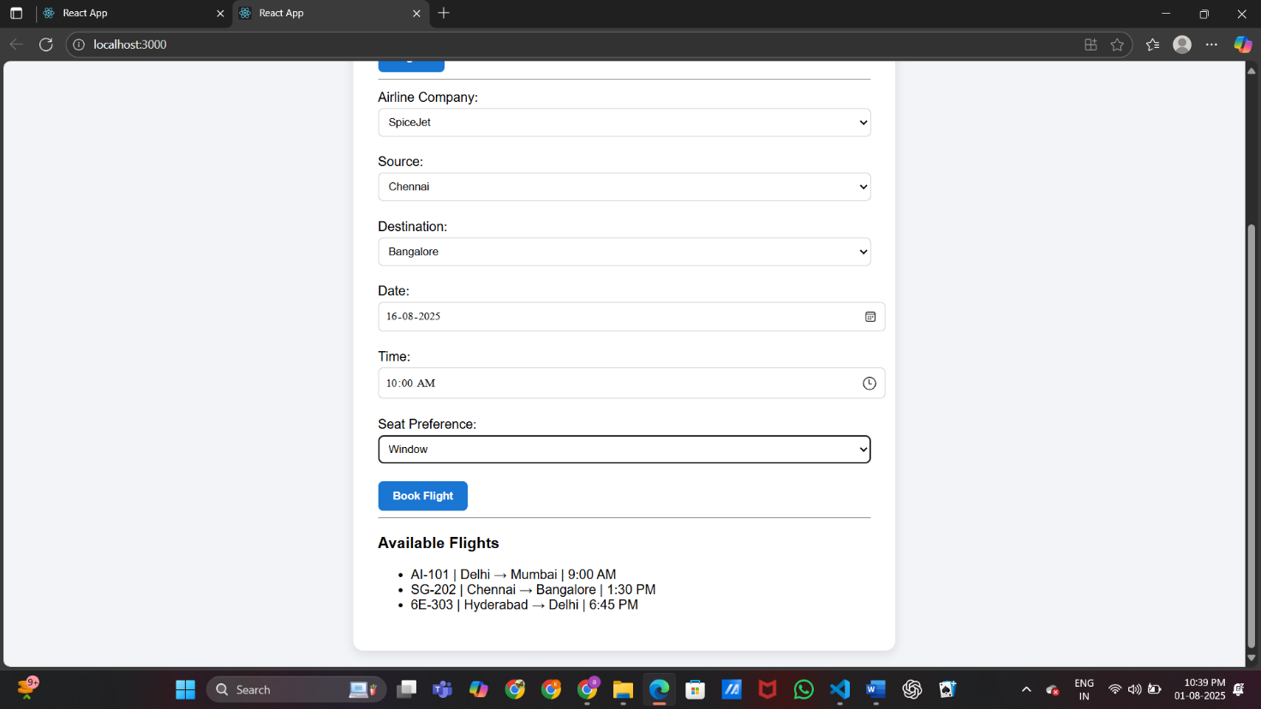

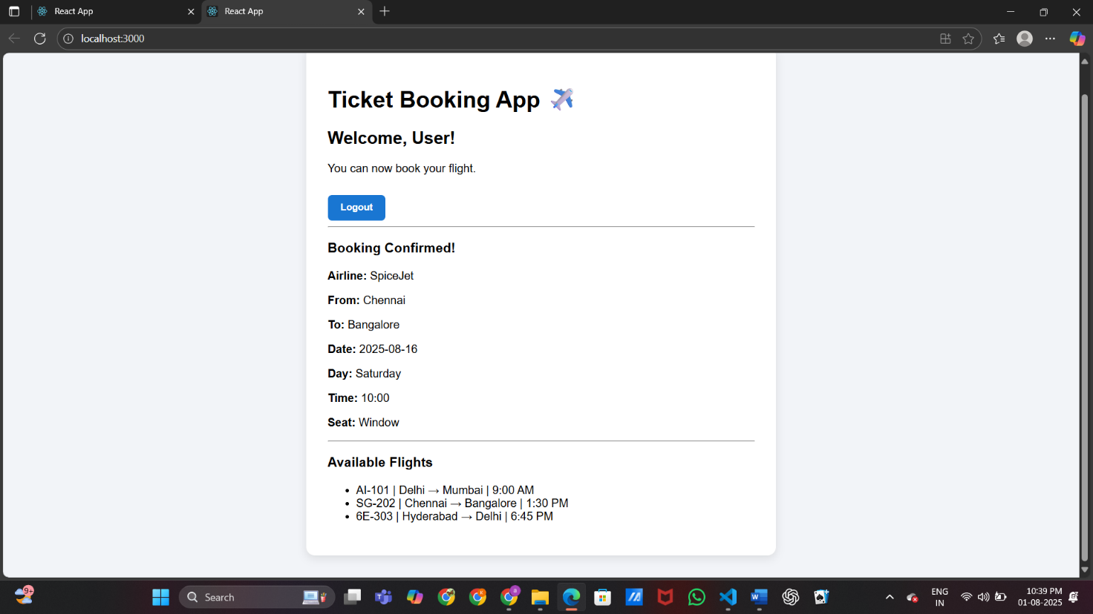

**Exercise 13 -** Blogger App

*App.js*

import React, { useState } from 'react';

import BookDetails from './BookDetails';

import BlogDetails from './BlogDetails';

import CourseDetails from './CourseDetails';

import './App.css';

function App() {

  const [selected, setSelected] = useState('');

  const renderComponent = () => {

    if (selected === 'books') {

      return <BookDetails />;

    } else if (selected === 'blogs') {

      return <BlogDetails />;

    } else if (selected === 'courses') {

      return <CourseDetails />;

    } else {

      return <p>Please select a category above.</p>;

    }

  };

  return (

    <div className="app-container">

      <h1>Blogger App 📚📝🎓</h1>

      <div className="buttons">

        <button onClick={() => setSelected('books')}>Book Details</button>

        <button onClick={() => setSelected('blogs')}>Blog Details</button>

        <button onClick={() => setSelected('courses')}>Course Details</button>

      </div>

      <div className="content-box">

        {selected && <h3>Selected: {selected.toUpperCase()}</h3>}

        {renderComponent()}

      </div>

    </div>

  );

}

export default App;

*BookDetails.js*

import React from 'react';

function BookDetails() {

  const books = [

    { id: 1, title: "Atomic Habits", author: "James Clear" },

    { id: 2, title: "Ikigai", author: "Francesc Miralles" },

    { id: 3, title: "Deep Work", author: "Cal Newport" }

  ];

  return (

    <div>

      <h4>Book List</h4>

      <ul>

        {books.map(book => (

          <li key={book.id}>

            <strong>{book.title}</strong> — {book.author}

          </li>

        ))}

      </ul>

    </div>

  );

}

export default BookDetails;

*BlogDetails.js*

import React from 'react';

function BlogDetails() {

  const blogs = [

    { id: 101, title: "React Basics", author: "DevAuthor" },

    { id: 102, title: "Hooks in Depth", author: "CoderJohn" }

  ];

  return (

    <>

      {blogs.length > 0 ? (

        <div>

          <h4>Blog Articles</h4>

          {blogs.map(blog => (

            <div key={blog.id}>

              <p><strong>{blog.title}</strong> — {blog.author}</p>

            </div>

          ))}

        </div>

      ) : (

        <p>No blogs found.</p>

      )}

    </>

  );

}

export default BlogDetails;

*CouseDetails.js*

import React, { useState } from 'react';

import './App.css'; // make sure to import your CSS

function CourseDetails() {

  const courses = [

    { id: 1, title: 'React for Beginners', instructor: 'John Doe', cost: 1499 },

    { id: 2, title: 'Advanced JavaScript', instructor: 'Jane Smith', cost: 1299 },

    { id: 3, title: 'Fullstack Development', instructor: 'Alice Brown', cost: 1999 },

  ];

  const [selectedId, setSelectedId] = useState('');

  const [bookedCourse, setBookedCourse] = useState(null);

  const selectedCourse = courses.find(course => course.id === parseInt(selectedId));

  const handleBook = () => {

    if (selectedCourse) {

      setBookedCourse(selectedCourse);

    }

  };

  return (

    <div className="course-container">

      <h4>Available Courses</h4>

      <label>Select a course:</label>

      <select value={selectedId} onChange={(e) => setSelectedId(e.target.value)}>

        <option value="">-- Select --</option>

        {courses.map(course => (

          <option key={course.id} value={course.id}>

            {course.title}

          </option>

        ))}

      </select>

      {selectedCourse && (

        <div className="course-details">

          <p><strong>Course:</strong> {selectedCourse.title}</p>

          <p><strong>Instructor:</strong> {selectedCourse.instructor}</p>

          <p><strong>Cost:</strong> ₹{selectedCourse.cost}</p>

          <button className="enroll-button" onClick={handleBook}>Book Course</button>

        </div>

      )}

      {bookedCourse && (

        <div className="booking-confirmation">

          <h4>✅ Booking Confirmed!</h4>

          <p>You have successfully booked <strong>{bookedCourse.title}</strong> with {bookedCourse.instructor}.</p>

          <p>🙏 Thank you for booking with us!</p>

        </div>

      )}

    </div>

  );

}

export default CourseDetails;

*App.css*

.app-container {

  font-family: Arial, sans-serif;

  padding: 20px;

  max-width: 700px;

  margin: auto;

}

.buttons button {

  margin: 5px;

  padding: 8px 14px;

  font-weight: bold;

  background-color: #1976d2;

  color: white;

  border: none;

  border-radius: 6px;

  cursor: pointer;

}

.buttons button:hover {

  background-color: #1255a1;

}

.content-box {

  margin-top: 20px;

  background-color: #f2f4f8;

  padding: 20px;

  border-radius: 8px;

}

.thank-you {

  margin-top: 10px;

  font-weight: bold;

  color: #2e7d32;

}

.course-container {

  background-color: #ffffff;

  padding: 24px;

  border-radius: 12px;

  box-shadow: 0 4px 20px rgba(0, 0, 0, 0.1);

  margin-top: 20px;

}

.course-container h4 {

  font-size: 20px;

  margin-bottom: 16px;

  color: #2c3e50;

}

.course-container label {

  display: block;

  margin-bottom: 8px;

  font-weight: 600;

  color: #555;

}

.course-container select {

  width: 100%;

  padding: 10px;

  margin-bottom: 16px;

  border-radius: 8px;

  border: 1px solid #ccc;

  font-size: 16px;

}

.course-details {

  margin-top: 16px;

  padding: 16px;

  background-color: #f9f9f9;

  border-left: 4px solid #1976d2;

  border-radius: 6px;

}

.course-details p {

  margin: 6px 0;

  color: #333;

}

.enroll-button {

  margin-top: 10px;

  padding: 10px 20px;

  background-color: #1976d2;

  color: white;

  font-weight: bold;

  border: none;

  border-radius: 8px;

  cursor: pointer;

  transition: background 0.3s;

}

.enroll-button:hover {

  background-color: #0d47a1;

}

.booking-confirmation {

  margin-top: 24px;

  background-color: #e0f7e9;

  padding: 16px;

  border-radius: 8px;

  border-left: 4px solid #2e7d32;

}

.booking-confirmation h4 {

  color: #2e7d32;

}

.booking-confirmation p {

  color: #333;

  margin: 4px 0;

  font-weight: 500;

}

**Output:**

